Material provided by Centro ASSIST as part of the service may not be retransmitted, reproduced or otherwise distributed or used in any form without the express written consent of Centro ASSIST.
© 2020 Holocentric Pty Ltd, trading as Centro ASSIST
ABN 73 052 972 095

Entry and exit policy
Easy English Version
Prepared by Centro ASSIST

Version 1.0

Entry and exit policy
 |  | About this document  Our services are available to people eligible for the NDIS.
 | We will always make sure that entering and exiting our services is as easy as possible.
 | This document will tell you about:  - how we will help you decide if our services are right for you  - how we will help you get started with our services  - when services might need to finish  - how we will help you switch from our service to another service.

 | Contacting us  The first step to getting access to our services is contacting us.  You can contact us by:
 | - calling us
 | - sending us an email
 | - letting us know in person.

 | A member of our team will reply to you and let you know what happens next. This marks the beginning of service entry.
 | We will always respond to you as quickly as possible.

 | Entry assessment  We want to make sure that the services we offer suit your:
 | - goals
 | - needs; and
 | - preferences.
 | This is called assessment.

 | We will meet discuss your goals, needs and preferences with:
 | - you
 | - your family and/or guardians
 | - your advocate
 | - other service providers that are helping you.

 | When assessing if you can enter into our service, we will think about:  - if you are eligible for the NDIS  - if we have the right physical resources to help you (e.g. rooms and spaces, tools and equipment, transport options.)  - if we have workers that can help you effectively  - if there are other services in the area that could help you better.

 |  | How we will help you get started  We will provide written confirmation that you have been accepted for our services.
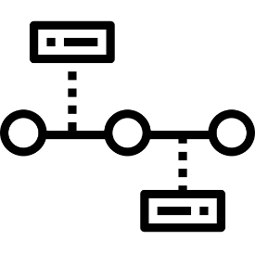 | We will give you a clear timeline for entry, including the date your services will start.
 | We will have meetings with you and other people that help to support you.
 | The goal of these meetings will be to come up with a service agreement.
 | Our goal is to have a service agreement that fully meets your goals, needs and preferences.

 | You have full choice about what services you get from us and how they are provided.
 | We will make sure to give the time and help you need to make decisions.
 | We will also let you know about any additional services available in your area.

 |  | Choosing to exit  If you want to stop receiving services from us, you can let us know at any time. This is called exiting.
 | Some reasons why you may choose to exit include:
 | - moving to a different area (too far away to reach us)
 | - transferring to a different service provider
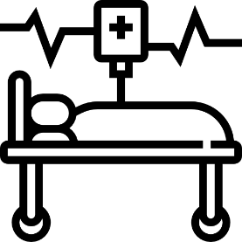 | - changes in your health.

 | If your choice to exit is linked with an incident or complaint, we will make sure to help you resolve this (please see Incident management and Feedback and complaint easy reads).
 | You can change your mind about exiting. We will give you plenty of time to make a final decision.
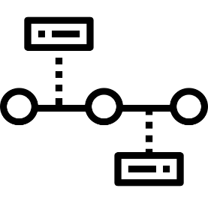 | If you decide to exit, we will give you a clear timeline for exiting, including the date your services will finish.

 |  | Why you might have to exit  We might ask you to exit our services.
 | Some reasons why we might ask you to leave our services include:
 | - your goals have changed and we cannot help you with your new goals
 | - there are problems with paying for services
 | - we no longer have the resources (e.g. workers or facilities) to provide the help you need

 | - we are shutting down.
 | We will ask you to exit in person and in writing.
 | We will always give you reasons why you are being asked to exit.
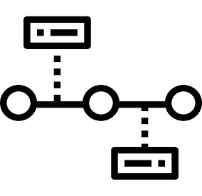 | We will give you a clear timeline for exiting, including the date your services will finish.
 | We will give you plenty of notice before stopping services.
 | We will always help you to find a new service provider after you exit and help you to create a transition plan.

 |  | Transition plans  When you enter or exit a service, we will create a transition plan.
 | A transition plan is made to make sure changing service providers is as easy as possible.
 | We will make sure the transition plan is suited to your goals, needs and preferences.
 | We will make sure to help you with any risks that might come from changing providers.

 | We will meet discuss your transition with:
 | - you
 | - your family and/or guardians
 | - your advocate
 | - other service providers that are helping you.

