This document and its contents are copyright of Centro ASSIST© 2020. All rights reserved.
Any redistribution, retransmission or distribution of part or all of the contents in any form without our express written permission is prohibited other than the following:

- you may share and use with your clients, NDIS participants, to aid communication
- you may share and use with employees to assist in their work
© 2020 Holocentric Pty Ltd, trading as Centro ASSIST
ABN 73 052 972 095

Duty of care and dignity of risk policy
Easy English Version
Prepared by Centro ASSIST

Version 2.0

Duty of care and dignity of risk policy
 |  | About this document  We will make sure you are always able to make choices for yourself.
 | Making your own choices can make you feel:  - special  - independent  - smart  - in control.
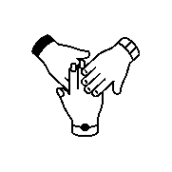 | All our workers want to let you make decisions all the time, but sometimes they have to help you. This is called a duty of care.

 | This document will:
 | - talk about how you can make decisions
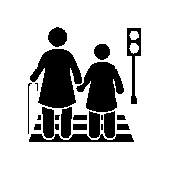 | - explain why sometimes a worker might have to help you make a decision
 | - what may happen when you make decisions.

 | Dignity of risk  Dignity of risk means you are allowed make decisions and choices of what you can and cannot do.
You are always allowed to make your own decisions.
An example of decisions you can make, may be:
 | - choosing to ride a bike
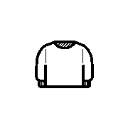 | - choosing to wear a nice jumper
 | - choosing to eat something yummy.

 | You are allowed to make mistakes.
 | You are allowed to have accidents.
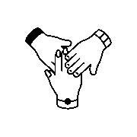 | We will always continue to support you, even if a mistake or accident happens when you make a decision.

 | What is duty of care?  A duty of care means your workers have to help keep you safe.
 | Sometimes if you make a decision a support worker might need to help you.  A support worker might help you make a decision, if the decision:
 | - could hurt you
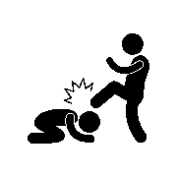 | - could hurt someone else
 | If your support worker thinks that your decisions could hurt you or could hurt someone else, they must try to help you.

 | A support worker may help you make a decision by:
 | - talking about what might happen
 | - making some changes, to make the space you are in safer
 | - helping you to do the activity.
 | Sometimes it may be too dangerous, and the support worker might need to stop you from making the decision.

 | This might make you feel:  - sad  - angry  - confused.
 | The support worker will always tell you why they stopped you from making a decision.
 | You and the support worker can talk about why your decision was stopped and ways you can safely make the decision.

 | How to get help  If you think your support worker has stopped you from making a decision unfairly, you are allowed to make a complaint. (See Feedback and complaints easy read).
 | If you think your support worker knew you would get hurt and didn’t help you, you are allowed to make a complaint.
 | We will help you make a complaint if you decide to do this.

