Material provided by Centro ASSIST as part of the service may not be retransmitted, reproduced or otherwise distributed or used in any form without the express written consent of Centro ASSIST.
© 2021 Holocentric Pty Ltd, trading as Centro ASSIST
ABN 73 052 972 095

Conflict of interest policy
Easy English Version
Prepared by Centro ASSIST

Version 1.0

Conflict of interest policy
 |  | About this document  Our workers have a responsibility to provide you with the best services possible.
 | A conflict of interest is when a person’s personal interests clash with their responsibilities.
 | This can make a person use the organisation’s money or power to benefit their family/friends.
 | This document will:  - explain different types of conflicts of interest  - give examples of conflicts of interest  - tell you how we stop conflicts of interest from happening  - tell you how we will make sure that conflicts of interest do not affect your choices  - tell you how to report a conflict of interest.

 |  | Types of conflicts of interest  There are three main types of conflicts of interest.
 | An actual conflict of interest means the conflict of interest happened.
 | A potential conflict of interest means something might turn into a conflict of interest.
 | A perceived conflict of interest means that it seems like there might be a conflict of interest.

 |  | Examples of conflicts of interest  Some examples of conflicts of interest can include:
 | - a support worker referring you to a service run by their family member/friend
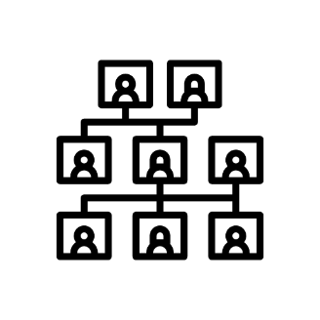 | - a support worker being related to their manager
 | - a client giving a big gift to a support worker.

 |  | How will we stop conflicts of interest from happening? Our goal is to avoid conflicts of interest as much as possible.
 | We always want to make sure that the help we provide and the advice we give you is free from any conflicts of interest.
 | We require that all workers at our organisation tell us about any actual, potential or perceived conflicts of interest.
 | We will work with our support workers to make sure that everything is fair at all times.
 | We will write down information about all conflicts of interest and make plans to fix them.

 |  | How will we make sure your choices are not affected by conflicts of interest? We always aim to make sure that conflicts of interest do not affect the choices you make.
 | To do this, we will give you all the information needed to help you make the best and fairest choice.
 | You can always change your mind about any choices you have made.
 | If needed, we will help you find an advocate to assist you with making fair choices (please see Advocacy easy read).
 | We will NOT let support workers benefit from a conflict of interest.
 |  | What happens if you find out about a conflict of interest? If you want to let us know about a conflict of interest we will support you.
 | You can let us know about a conflict of interest by:  - writing to us  - sending us an email  - calling us on the phone  - speaking to someone.

