Material provided by Centro ASSIST as part of the service may not be retransmitted, reproduced or otherwise distributed or used in any form without the express written consent of Centro ASSIST.
© 2022 Holocentric Pty Ltd, trading as Centro ASSIST
ABN 73 052 972 095

Child safe policy
Easy English Version
Prepared by Centro ASSIST

Version 1.0

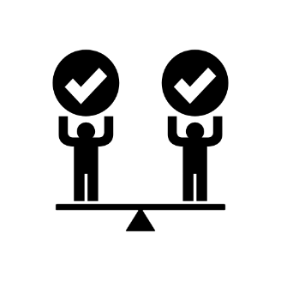 |  | About this document  Every child and young person deserves to feel safe.
 | We are committed to providing an environment that aligns with the National Child Safe Principles.
 | This document outlines how we will help children and young people feel safe and welcome.
 | This document should be read together with other easy read documents.
 | Other easy read documents you will be given will give you more information about our service.
 | Other easy read documents that are available include:  - Abuse neglect and exploitation  - Advocacy  - COVID-19  - Entry and exit  - Decision making and consent  - Duty of care and dignity of risk  - Participant induction pack  - Privacy and confidentiality  - Feedback and complaints  - Incident management  - Infection control  - Participant rights

 |  | Our commitment to child safety  We will provide an environment that:  - actively promotes the wellbeing and safety of children  - seeks out the views of children and young people on issues that matter to them  - takes action to protect children and young people from harm.
 | You have the right to be heard, especially when you do not feel safe or well. We want you to tell us how you think we can improve your safety and wellbeing
 | We will actively identify and act on any risks to the safety and wellbeing of children and young people.
 | We are committed to all children and young people regardless of ability, sex, gender or background.
 | We will treat children, their families, and other workers with respect and courtesy and demonstrate appropriate personal and professional boundaries.

 | Everybody in our organisation will be trained to understand this policy and sign our Child safe code of conduct.
 | We will not disclose information about a child (including images) without consent, unless we have to make a report.
 | We will respond to concerns or complaints promptly and report any suspected harm to management and any state requirements.
 | We will not use inappropriate language around children, or provide access to inappropriate images or material.

 | Where children or young people access the internet and social media, we will promote safe use of online applications to learn, communicate and seek help.
 | We will make sure that every worker in our organisation is cleared and suitable to work with children and young people.

