This document and its contents are copyright of Centro ASSIST© 2020. All rights reserved.
Any redistribution, retransmission or distribution of part or all of the contents in any form without our express written permission is prohibited other than the following:

- you may share and use with your clients, NDIS participants, to aid communication
- you may share and use with employees to assist in their work
© 2020 Holocentric Pty Ltd, trading as Centro ASSIST
ABN 73 052 972 095

Abuse, neglect and exploitation policy
Easy English Version
Prepared by Centro ASSIST

Version 2.0

Abuse, neglect and exploitation policy
 |  | About this document  We will make sure that you always feel safe when you get help from us.
 | Abuse, neglect and exploitation can make you feel:  - sad  - angry  - scared  - confused.
 | All our workers know that abuse, neglect and exploitation is NEVER allowed.  This document will:  - help you understand abuse, neglect and exploitation  - tell you how to seek help

 | Please note: This document discusses sensitive topics. If you feel upset or uncomfortable please let us know. We will help you to understand this information in a different way.

What is abuse?
Abuse is any action that is designed to hurt another person. There are different types of abuse.
 | Physical abuse is when someone hurts any part of another person’s body.  For example: punching, kicking, hitting or preventing the other person from moving freely.
 | Emotional abuse is when someone says mean things to hurt someone else.  For example: screaming or making rude comments because they know it will make the other person feel upset.
 | Financial abuse is when someone uses money to control another person.  For example: stopping another person from using their own money or bank accounts.
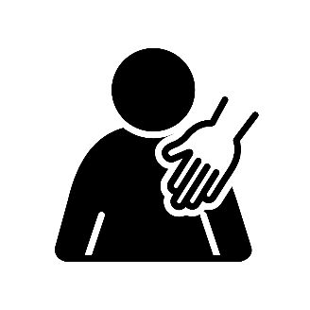 | Sexual abuse is when someone talks about sexual topics or touches another person’s body when the other person has not given permission for this to happen.  For example: touching the private parts of a person’s body or making inappropriate comments about a person’s appearance.
 | Cultural abuse is when someone uses another person’s culture to cause harm or to control them.  For example: making racist comments or refusing to let the other person speak their native language.

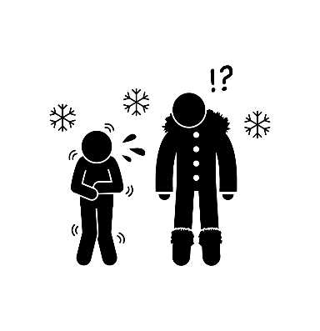 |  | What is neglect?  Neglect is when a person is not given the care that they need. Some signs of neglect are:
 | - quickly losing or gaining weight because of a bad diet
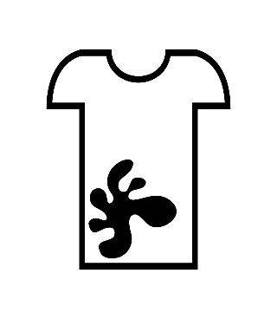 | - dirty clothes and/or clothes that do not fit
 | - not having your needs and preferences met when planning/providing you with services.
 | If you think we are not meeting your needs, let one of our workers know. We are here to help.

What is exploitation?
Exploitation is the act of treating a person unfairly in order to benefit from their work or resources. Some examples of exploitation are:
 | - a company not paying someone for their work (if the person did not agree to be a volunteer)
 | - a worker using a person’s disability benefits to buy things that do not help that person
 | - an email from someone you do not know asking for personal information and bank details.

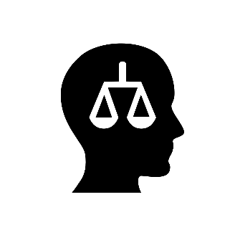 |  | What is reasonable force?  Reasonable force is an action that is done to prevent harm.  We will only use reasonable force to keep you safe.  Our workers can use reasonable force to stop you from:
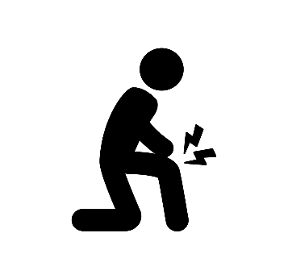 | - harming yourself or others
 | - damaging things on purpose
 | - being in harm’s way (e.g. if you are in the path of a falling object).

 |  | How to get help  You should make a complaint or report an incident if you experience abuse, neglect or exploitation. We will help you to do this.
 | Family members, advocates or friends can also help you make a complaint or report an incident.  You can make a complaint/report and incident by:
 | - letting a worker know about the situation
 | - sending an email, or
 | - making a phone call.
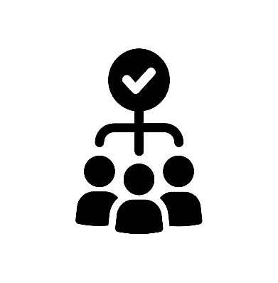 | We will work solve the problem and involve other organisations (such as the NDIS Commission) when needed.
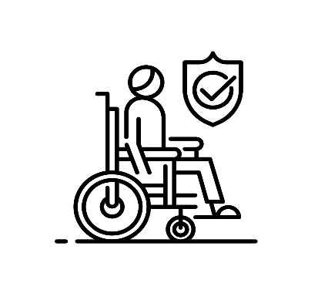 | If you believe that we have not handled your incident/complaint in the right way, you can make a complaint about us directly to the NDIS.  We will help you if you decide to do this.

